WFM Agent Performance Analysis

Python, SQL, and Power BI Project

1. Project Overview
Workforce Management (WFM) analytics is essential for improving call center efficiency and monitoring agent productivity. Organizations rely on metrics such as Average Handle Time (AHT), Occupancy, Utilization, and Shrinkage to evaluate operational performance.
This project analyzes call center agent performance using Python for data analysis, SQL for structured metric calculation, and Power BI for dashboard visualization.
The goal of this project is to identify productivity patterns, evaluate operational efficiency, and develop a Productivity Score model to rank agents based on key workforce metrics.

2. Project Workflow
The project follows an end-to-end data analytics workflow:
Data Collection
→ Python Data Analysis
→ SQL Data Transformation
→ Power BI Dashboard Visualization
Python was used as the initial analysis tool to explore the dataset and perform feature engineering.

3. Tools and Technologies
The following tools were used in the project:
Python
• Pandas
MySQL
• Data transformation
• KPI calculations
• Views and ranking logic
Power BI
• Interactive dashboards
• Operational performance visualization

4. Dataset Description
The dataset contains operational metrics for call center agents.
Key fields include:
Agent ID
Agent name
Team
Gender
Age
Shift Timing
Calls Handled
Average Talk Time
Average Hold Time
Break Time
Training Time
Login Time
Attendance Status
Date

5. Python Data Analysis
Python was used as the first step to perform exploratory data analysis (EDA) and feature engineering.

Data Cleaning
Using Pandas, the dataset was cleaned by:
• Converting date columns to datetime format
• Handling missing values
• Standardizing time-based fields
Example Python operation:
time_cols = [
"tea_break_time",
"lunch_break_time",
"bio_break_time",
"training_time",
"talk_time",
"hold_time",
"after_call_work",
"avg_handle_time",
"total_login"
]

for col in time_cols:
df[col] = df[col].astype(str).str.split().str[-1]

from sqlalchemy import create_engine

username = "root"
password = "1234"
host = "localhost"
port = "3306"
database = "WFM_PROJECT"

engine = create_engine(f"mysql+pymysql://{username}:{password}@{host}:{port}/{database}")

table_name = "agent_performance"
df.to_sql(table_name, engine, if_exists="replace", index=False)

pd.read_sql("SELECT * FROM agent_performance LIMIT 5;", engine)

6. SQL Data Transformation
After performing initial analysis in Python, the dataset was processed in MySQL to calculate operational metrics and create structured analytical views.
Key SQL techniques used:
• Window Functions
• Views
• Aggregations
These transformations prepared the data for dashboard visualization.

7. Workforce Metrics Calculated
Several industry-standard WFM metrics were calculated.
Total Handle Time
Represents total time spent handling calls.
Total Handle Time =
(Talk Time + Hold Time) × Calls Handled

Average Handle Time (AHT)
AHT =
Total Handle Time / Calls Handled

Effective Work Hours
Effective Work Hours =
Total Login Time – Break Time – Training Time

Occupancy
Occupancy =
Total Handle Time / Effective Work Hours

Utilization
Utilization =
Effective Work Hours / Total Login Time
Shrinkage
Shrinkage =
(Break Time + Training Time) / Total Login Time

8. Productivity Scoring Model
A weighted productivity model was developed to evaluate agent performance.
Productivity Score =
(AHT Score × 0.4)
- (Occupancy × 0.3)
- (Utilization × 0.3)
Agents were ranked using SQL window functions to identify top performers within each team.
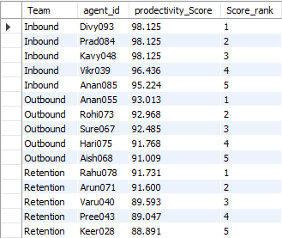

9. Power BI Dashboard
A Power BI dashboard was developed to present insights interactively.
The dashboard includes three major sections.
Executive Overview
Displays high-level KPIs:
Total Calls
Average Handle Time
Occupancy
Utilization
Shows:
Team Occupancy
Calls Handled by Age
Agent Occupancy Distribution
AHT by Shift Timings
Productivity Distribution
Interactive slicers allow filtering by:
Team
Gender
Age Category
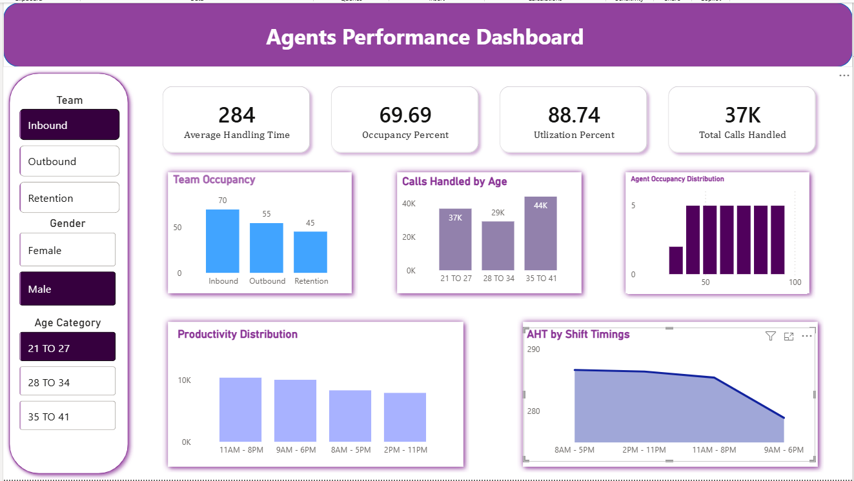

10. Key Insights
Several operational insights were identified.
Certain teams consistently handle higher call volumes.
The 11 AM – 8 PM shift handles the highest number of calls.
Agents aged 21–27 show higher productivity levels.
Utilization has a strong impact on overall productivity score.
Shrinkage varies significantly across teams and operational periods.

11. Conclusion
This project demonstrates how workforce management data can be analyzed to improve operational performance.
By integrating Python, SQL, and Power BI, the project provides a complete data analytics pipeline from exploration to visualization.
The insights generated can support better workforce planning, improved agent productivity, and data-driven operational decision-making.

